How to spot if a chemical is Hazardous:
To identify if a substance is hazardous, check the product's container label and/or the SDS which is available from the supplier. If a product is not classified as a hazardous chemical under the Work Health and Safety Act 2011, a SDS is not required and therefore may not be available.
If you are unsure, always check with the product's supplier. The labels of hazardous chemicals usually contain the words 'danger' or 'warning', along with relevant pictograms and details of hazards.
e.g.
For “Resolve’
- Locate the SDS by typing into Chrome “Resolve Whiteley SDS”
- Download the SDS and save it to a new folder in “Hazardous Chemicals” called “Workshop SDS”
- Enter it into the spreadsheet as H for “Hazardous”

Section 2 is the place to look to see if it is hazardous
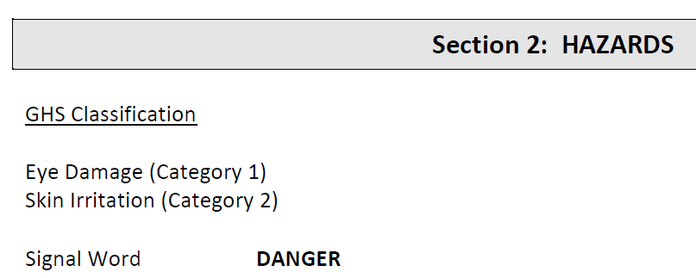
On other SDS, signs called ‘Pictograms” will also indicate if the chemical is hazardous. They look like this
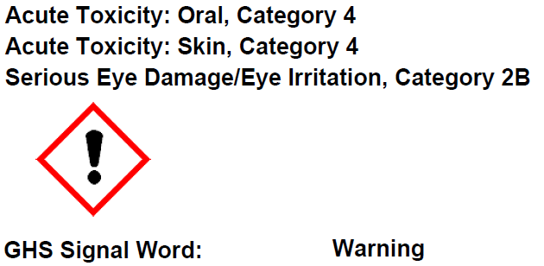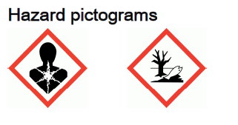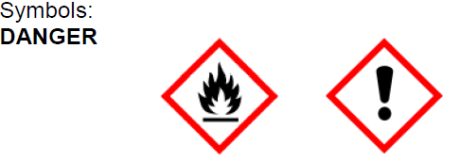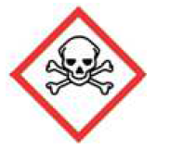
Words that indicate Hazardous include:
Toxic, Hazardous to the aquatic environment, May cause allergic skin reaction, Causes damage to the nervous system, Combustable liquid, Fatal if swallowed.

- Now, because it is hazardous it must have a current SDS so look for the date the SDS was issued.
The date is often on the first page at the top right or in the footer.
The correct date is the date issued or reviewed.
For Resolve, the date is on the last page and is 14Th. April 2021.
I have entered this into the spreadsheet to be reviewed in 5 years,, 2026

When we identify all the hazardous chemicals, we will put them in alphabetical order into the folder with the spreadsheet at the front.
Review the list of chemicals each year for each location.
When you locate a non-hazardous (NH) chemical, it is entered into the spreadsheet as NH and the date. You do not need to download, save, print, or insert NH, SDS into the folder.
Do the best you can and I will assist you to find the missing ones next time I see you.

